User manual (**Element wise Multiplication**)

/*

* Element wise Multiplication

* This CUDA code can handle/work with any type of the input mxArrays,

* GPUarray or standard matlab CPU array as input {prhs [0], prhs [1]:= mxGPUArray or CPU Array}

* GpuArray output, C=ELM_CUDA (A, B) or C3=ELM_CUDA_3D (A3, B3)

* Developed at UCL, Institute of Neurology, 12 Queen Square, WC1N 3AR, London

* Welcome Trust Centre for Neuroimaging

* Part of the project SPM (http://www.fil.ion.ucl.ac.uk/spm)

* Copyright 2018

* Kevin Bronik

*/

Replacing Matlab operator “.*” with parallel Matlab-CUDA syntax

Hadamard product (matrices)

**Reference:** From Wikipedia, the free encyclopaedia

[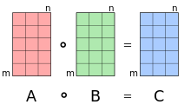](https://en.wikipedia.org/wiki/File:Hadamard_product_qtl1.svg)

The Hadamard product operates on identically-shaped matrices and produces a third matrix of the same dimensions.

In [mathematics](https://en.wikipedia.org/wiki/Mathematics), the **Hadamard product** (also known as the **Schur product**[[1]](https://en.wikipedia.org/wiki/Hadamard_product_(matrices)#cite_note-1) or the **entry wise product** is a [binary operation](https://en.wikipedia.org/wiki/Binary_operation) that takes two [matrices](https://en.wikipedia.org/wiki/Matrix_(mathematics)) of the same dimensions, and produces another matrix where each element *i,j* is the product of elements *i,j* of the original two matrices. It should not be confused with the more common [matrix product](https://en.wikipedia.org/wiki/Matrix_multiplication). It is attributed to, and named after, either French mathematician [Jacques Hadamard](https://en.wikipedia.org/wiki/Jacques_Hadamard), or German mathematician [Issai Schur](https://en.wikipedia.org/wiki/Issai_Schur).

The Hadamard product is [associative](https://en.wikipedia.org/wiki/Associative) and [distributive](https://en.wikipedia.org/wiki/Distributive_property), and unlike the matrix product it is also [commutative](https://en.wikipedia.org/wiki/Commutative).

**Examples:**

**(First example**)

**3D image processing using element wise multiplication**

This example shows how to process two colour images using the three-dimensional Element wise Multiplication

Read an image into the workspace, then convert the image to double.

[X,map] = imread('photo.tiff');

if ~isempty(map)

Im1 = ind2rgb(X,map);

end

[Y,map] = imread('gibson_robotlp_red.tiff');

if ~isempty(map)

Im2 = ind2rgb(Y,map);

end

Perform a 3D Element wise Multiplication of the colour images using the ELM_CUDA_3D function.

K = ELM_CUDA_3D (Im1, Im2);

Display the original colour image alongside the processed image.

figure

imshowpair(Im1,Im2,'montage')

title('Two original colour images (Left) and (Right)');

Before Processing:

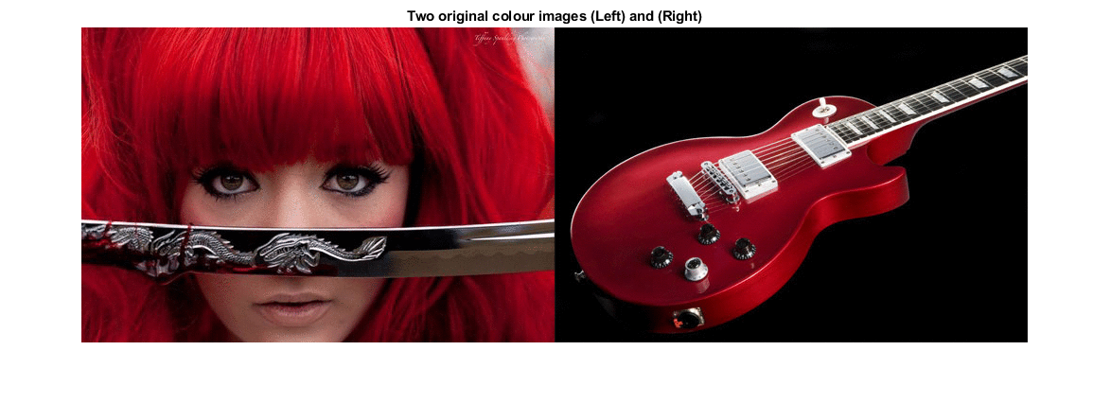

>> whos Im1, Im2

Name Size Bytes Class Attributes

Im1, Im2 333x500x3 (Image Dimensions) 3996000 double

After Processing [K = ELM_CUDA_3D (Im1, Im2)]:

figure

imshowpair(Im1,K,'montage')

title('Original colour image (Left) and processed image (Right)');

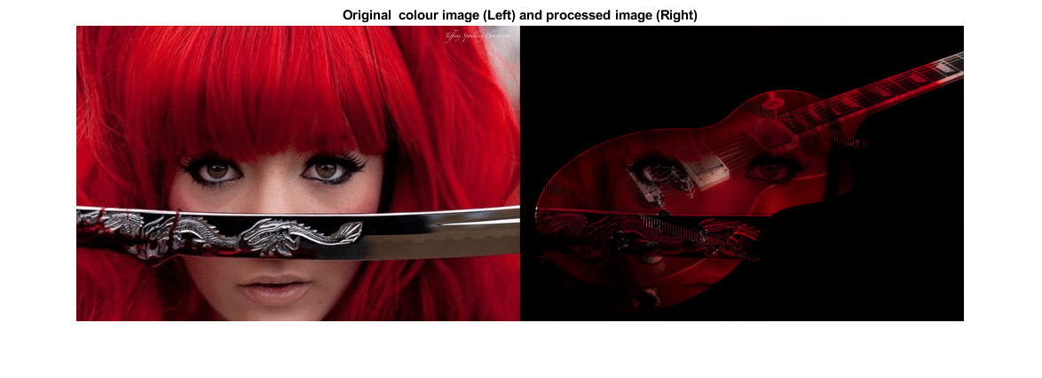

**(Second example**)

>> A 🡨--- (3D input array)

A(:,:,1) =

1 2 3

4 5 6

7 8 9

A(:,:,2) =

10 11 12

13 14 15

16 17 18

A(:,:,3) =

19 20 21

22 23 24

25 26 27

>> B 🡨--- (3D input array)

B(:,:,1) =

1 2 3

4 5 6

7 8 9

B(:,:,2) =

10 11 12

13 14 15

16 17 18

B(:,:,3) =

19 20 21

22 23 24

25 26 27

>> A=gpuArray (A) 🡨--- (To get maximum performance)

>> B=gpuArray (B)

>> C=**ELM_CUDA_3D** (A, B) 🡨--- (3D output array-gpuArray)

C(:,:,1) =

1 4 9

16 25 36

49 64 81

C(:,:,2) =

100 121 144

169 196 225

256 289 324

C(:,:,3) =

361 400 441

484 529 576

625 676 729

>>

To compile:

First try the method described here:

<https://uk.mathworks.com/help/distcomp/run-mex-functions-containing-cuda-code.html>

After successful compiling running and testing then simply try following statement (copy and paste in Matlab and enter):

>> debug_ELM_CUDA_cu(false)

See the file “debug_ELM_CUDA_cu.m”

{\displaystyle \left({\begin{array}{ccc}\mathrm {a} _{11}&\mathrm {a} _{12}&\mathrm {a} _{13}\\\mathrm {a} _{21}&\mathrm {a} _{22}&\mathrm {a} _{23}\\\mathrm {a} _{31}&\mathrm {a} _{32}&\mathrm {a} _{33}\end{array}}\right)\circ \left({\begin{array}{ccc}\mathrm {b} _{11}&\mathrm {b} _{12}&\mathrm {b} _{13}\\\mathrm {b} _{21}&\mathrm {b} _{22}&\mathrm {b} _{23}\\\mathrm {b} _{31}&\mathrm {b} _{32}&\mathrm {b} _{33}\end{array}}\right)=\left({\begin{array}{ccc}\mathrm {a} _{11}\,\mathrm {b} _{11}&\mathrm {a} _{12}\,\mathrm {b} _{12}&\mathrm {a} _{13}\,\mathrm {b} _{13}\\\mathrm {a} _{21}\,\mathrm {b} _{21}&\mathrm {a} _{22}\,\mathrm {b} _{22}&\mathrm {a} _{23}\,\mathrm {b} _{23}\\\mathrm {a} _{31}\,\mathrm {b} _{31}&\mathrm {a} _{32}\,\mathrm {b} _{32}&\mathrm {a} _{33}\,\mathrm {b} _{33}\end{array}}\right)}